­

# AMITY GLOBAL BUSINESS SCHOOL, PUNE AMITY UNIVERSITY

A

# TERM PAPER

ON

# “A STUDY ON CUSTOMER SATISFACTION OF ALCON HYUNDAI GOA”

SUBMITTED BY

**VIPLAV JEETENDRA LOTLIKAR** ENROLLMENT NO- A31501921001 COURSE: MBA

BATCH: **2021-to-2023**

UNDER THE GUIDANCE OF

# DR. SWETA SIDDHARTH

SUBMITTED IN THE PARTIAL FULFILLMENT OF

# Masters of Business Administration

**CERTIFICATE**

This is to certify that the project work titled

# “A STUDY ON CUSTOMER SATISFACTION OF ALCON HYUNDAI GOA”

Is a Bonafede work that is done by

# VIPLAV JEETENDRA LOTLIKAR

Enrollment No. **-** A31501921001 For the award degree of

# Masters of Business Administration

**DR. (COL) S. V. SHARMA DR. SWETA SIDDHARTH**

# DIRECTOR GENERAL

**INTERNAL FACULTY GUIDE AGBS, PUNE**

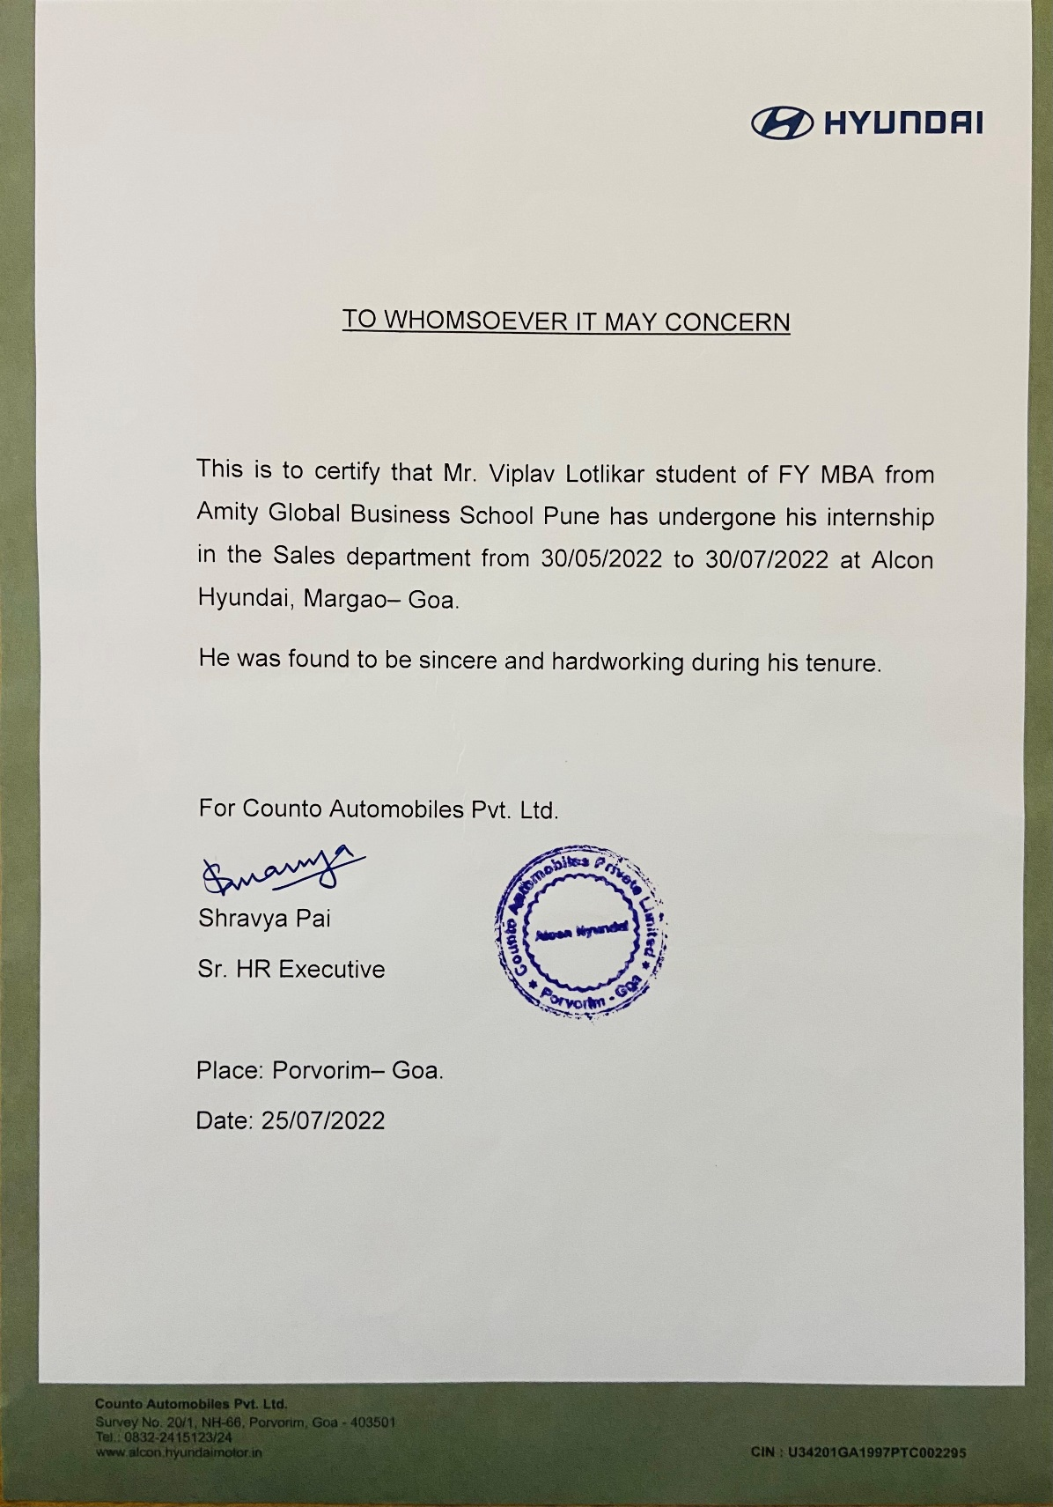

# DECLARATION

I, Viplav Jeetendra Lotlikar, a student of **Amity Global Business School, Pune** of BBA Batch 2018 to 2021 declare that the assignment report entitled “**A Study on Customer Satisfaction of Alcon Hyundai Goa”** is a bonafide record of the original project work that is carried out by me and has not been submitted earlier for any other degree or diploma.

I was regularly in contact with my Summer Assignment Guide (Dr. Sweta Siddharth) regarding any discussions with my assignment.

Date of Assignment Submission:

Name of the Candidate: **Viplav Jeetendra Lotlikar**

Signature of the Candidate:

Name of the Faculty Guide: **Dr. Sweta Siddharth**

Signature of the Internal Faculty Guide:

# CERTIFICATE OF ORIGIN

This is to certify that I, Viplav Jeetendra Lotlikar, a student of MBA 2021- 2023, Amity Global Business School, Pune has worked under the able guidance and supervision of Dr. Sweta Siddharth designation Internal Faculty Guide.

This project report has the requisite standard for the partial fulfillment of the Post Graduate Degree in Business Administration. To the best of my knowledge no part of this report has been reproduced from any other report and the contents are based on original research. I am aware that in case of non-compliance, Amity Global Business School, Pune is entitled to cancel the report.

Signature Viplav Lotlikar

# ACKNOWLEDGEMENT

I hereby take this opportunity to acknowledge all the people who have guided me along this report. A special gratitude to Amity Global Business school, Pune and to the Col (Dr.) Sneh V Sharma Director General, AGBS, Pune and I give it to my project guide, Dr. Sweta Siddharth whose contribution in stimulating suggestions and encouragement, helped me to coordinate my project especially in writing this report.

Furthermore, I would also like to acknowledge with much appreciation the crucial role of our library who gave the permission to use all required equipment and the necessary materials to complete the task.

# TABLE OF CONTENTS

|  |  |  |
| --- | --- | --- |
| **CHAPTER NO:** | **TOPICS** | **PAGE NO:** |
| **CHAPTER 1:** | **INTRODUCTION** | **9-12** |
| 1.1 | **ORGANIZATIONAL CHART** | **13** |
| 1.2 | **DEPARTMENTAL STUDY** | **14-21** |
| 1.3 | **SWOT ANALYSIS** | **22-24** |
| **CHAPTER 2:** | **PROJECT TITLE** | **25** |
| 2.1 | **OBJECTIVES** | **25** |
| 2.2 | **SCOPE OF STUDY** | **25** |
| 2.3 | **RESEARCH METHODOLOGY** | **26** |
| 2.4 | **LITERATURE REVIEW** | **27** |
| **CHAPTER 3:** | **DATA ANALYSIS** | **28-51** |
| **CHAPTER 4:** | **RECOMMENDATION** | **52-53** |
|  | **CONCLUSION** | **54** |
|  | **REFERENCE** | **55** |

**ABSTRACT**

Automobile has become an integral part of our lives, it is an add-on feature of living beings which gives us cheaper, quicker and more convenient mobility in day-to-day life. Behind this welfare, the credit goes to the hardship of those in the field, in the form of upgradation via technological research and development. The automotive component of Indian sector is nearly monopolized by around 500 entities which has more than 85% of the production achieved. Hyundai Motor Company, was announced as a self-dependent corporation in 1937. This project made on Hyundai gives us an idea about the contentment level of all the consumers with the company. Moreover, the introduction about this automobile industry has been explained in the project. As a joint venture has been formed between the Group and Hyundai Motor Corporation, Hyundai Motor Limited has been determined to share a significant role in the development of this industry and the establishment of opportunities for employment, not only through the network of its dealers, but also through numerous ancillary industries.This industry firmly believes that the favourable outcome of this venture highly depends on arranging a high-quality product and services to all its customers through the determination and teamwork of its teammates. Hyundai Motor Limited, along with its determined dealership and suppliers, has assembled the "Growing Together" philosophy of its parent Company TMC to create prolonged business growth. In this way, Hyundai Motor Limited has aimed to further contribute to the progress of the Indian automotive industry, by providing greater employment.

Opportunities for the local citizens, improve their quality of life of and encourage vigorous economic activity in India. The next stage of the study dwells into the research done for analyzing the response towards Hyundai. This has been done by conducting a survey.

Alcon Hyundai in Goa has been in operation since 2006 as an authorized sales and service outlet. The Senior Sales Manager is the head of the facility and hence is entitled with the responsibility of managing the entire showroom. The showroom has various departments like sales, service, commercial sales, insurance, true value, and accessories, spare parts, admin & accounts, human resource and back office. The showroom also has F&B, housekeeping, valet, security.

The Sales department is responsible for the sales of the vehicles and mainly aims to generate inquiries and convert them into sales. Customer Care department which is an integral part of the Sales department, focuses more on after sales services provided to the customers. Service department is the second most important department and therefore looks after the servicing of the vehicles before and after sale. The Insurance Department is responsible for issuing the insurance policy for new vehicles. It is also responsible for reminding the customers about insurance renewals and renewing the insurance policies of the previously sold vehicles. The stores department issues car parts as per the requirements. The Accounts department is responsible for maintaining the finances and accounts of the showroom. They have to keep a track record and manage the finances of all the departments in the company. The exchange department is responsible for handling the evaluation and exchange of old cars and sales of pre-owned cars. The Showroom hostess is responsible for welcoming the walk-in customers and guiding them to the Relationship Managers, they are also responsible for maintaining various registers i.e., inquiry registers, delivery registers, sales report registers, etc. and other documentation. The project was undertaken in the sales department of Alcon Hyundai, Counto Automobile Pvt. Ltd.

# CHAPTER I

**INTRODUCTION**

# Company Profile

Korea's top automaker is "Hyundai," a name to be respected in the global automobile market. With its transformation from a locally focused manufacturer to a worldwide player and significant contributor to Korea's economic and industrial development, Hyundai has created an impressive track record for growth in both quantitative and qualitative dimensions. As it works toward becoming a top-tier automaker, Hyundai Motor Company is growing steadily. Hyundai Business Group, the biggest conglomerate in the country, gave birth to Hyundai Motor Company (HMC) in December 1967 with the intention of entering the automotive sector to satisfy the expanding local demand for automobiles. Since that time, HMC has significantly contributed to the provision of transportation in support of Korea's economic development and prosperity. Hyundai Motor Company's entry into the Indian market. By forming a subsidiary called "Hyundai Motor India Limited" with a total investment of US$ 614 Million, Hyundai established its foothold in India. The Hyundai project is the biggest ever undertaken by a multinational corporation in the automotive industry. The largest Hyundai Motors manufacturing facility outside of Korea is located in Tamil Nadu, close to Chennai. It has almost all the equipment required for a self-sufficient manufacturing and production site for the development of automobiles. This assembly plant not only boasts its own assembly lines but also a research and

development lab, a performance testing lab, and a driving simulator. As a result, the India plant is an integrated family-style automotive assembly facility, competent of all production processes, research and development,testing the product, sales marketing, and post-sale support in India. At its global debut in New Delhi in 1997, Hyundai Motor India Limited unveiled "Santro," the best little automobile. Santro is just an "Atos" with a new face. Three distinct models of Santro were released, each with a distinctive set of characteristics. The Santro automobile, often known as the Tall Boy car, was a resounding success in the Indian market. Year after year, it led the volumes in its sector.

# Vision:

The fulfilment of Hyundai Motors is now being deliberated globally. As Hyundai Company is continuing to develop top-notch engines that will be the integral part of further generation cars, they are confident that they’ll be the major opponent of the automobile industry in the coming future.

# Mission:

According to their corporate concept, Hyundai wants to improve the lives of everyone in its immediate vicinity and become a household name. Hyundai has adopted the "Four Best" concept, which defines their novel ambitions: Providing best customer service, adopting foremost technology, providing best quality products, and giving best value for people nearby, to leap into the fourth ranks of the global auto industry in the upcoming centuries.

# Profile of Alcon Group

Anil Counto, the founder of Alcon Group, earned his degree in civil engineering from VJTI Engineering College in Mumbai in 1966. For the next four years, he obtained important experience working for private companies before joining the PWD as a young man just starting his career. But that is where the similarities end. Considering that this young man was on a mission to fulfill his vision. He also possessed the ability, the drive, and the resolve to succeed. You need only combine these ingredients with courage, honesty, dedication, and a strict work ethic to achieve success.

Alcon presently has five key business verticals, including construction, hospitality, manufacturing, trading, and infrastructure/logistics, expanded from a small engineering unit established in 1971. His small business is now among the biggest conglomerates in Goa. And the individual has emerged as one of the State's most well-known businessmen. Anil Counto was the man. And his organization: Alcon-Anil Counto Enterprises, the culmination of one man's unceasing efforts and his varied interests in the social, cultural, educational, and business fields.

A pioneer in Goa's construction industry with a history of successfully finishing many projects since its inception. Building residential and commercial spaces, hotels, resorts, etc. has benefited from our expertise in construction and the development of distinctive properties, giving us a competitive edge.

Due to the construction industry's success, JVs with ACC Limited and Ambuja Cement were formed. The first project produced a 500 TPD Clinker grinding and cement packing machine at Surla. The second endeavor was a first in Goa - the production of Ready Mixed Concrete. North and South Goa each have two Alcon plants. In their third joint venture, Ambuja Cement Limited creates microfine materials for concrete that are long-lasting and sustainable.

The establishment of a fully functional, cutting-edge research laboratory in Kundaim, Goa, was motivated by the success of Counto Micro fine Products, which featured products that were both firsts in India and the result of internal research and development. Along with the Green Building Centre, it was launched in 2018. In order to give students a platform to build a practical industrial outlook, GBC collaborates with educational institutions including IIT Goa, IIT Mumbai, and Goa College of Engineering. GBC incorporates all elements of an ecosystem, generating solutions using industrial waste/by-products.

Alcon has three properties in Goa in the hospitality sector: the Hotel Delmon, a city hotel with 50 keys in Panaji; the Ronil Beach Resort in Baga, Calangute; and the upscale restaurant O' Coqueiro in Porvorim. They work as automotive dealers for Mercedes Benz and Hyundai in the

luxury and mass market segments, respectively. Alcon also pushed into logistics, using jetties for raw material loading and unloading, finished products and other bulk materials.

Education, trusts for unique kids, and various socio-religious activities are all included in their social responsibilities.

# About Alcon Hyundai

Alcon Hyundai in Goa has been in operation since 2006 as an authorized sales and service outlet. They have quickly established themselves as a reputable name in Goa. Alcon Hyundai has made a point of upholding high standards for customer care ever since the company's beginnings. Alcon satisfies every criterion a four-wheeler vehicle might possibly have. The store guarantees the sale of these vehicles but also provides after-sale services. The sales staff carefully considers the needs of potential customers before making suggestions that are appropriate while outlining the features, specifications, and costs of the automobiles. Additionally, they offer genuine Hyundai parts and accessories.

# Organizational Charts

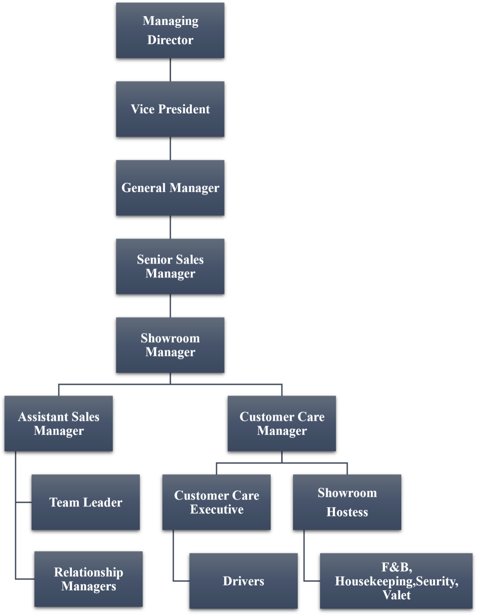

**Departmental Study**

The Senior Sales Manager is the head of the facility and hence is entitled with the responsibility of managing the entire showroom. All the department’s report directly to the Senior Sales Manager. The Senior Sales Manager also clarifies and sets the day-to-day goals for the showroom. He is responsible for maintaining the brand image and the goodwill of the showroom by standardizing and maintaining the quality of service provided to the customers.

# Sales Department

The sales department is responsible for the sales of the cars and generating revenue for the company. The main aim of this department is to generate enquiries and convert them into sales. They need to impart the right information about the vehicles to their customers. The department is also responsible for the upkeep of the test drive vehicles and to display the cars at the showroom. The department has to ensure that the vehicle is delivered to the customer on the promised date and time.

The Sales department is handled by the Senior Sales Manager who also plays a very important part in Manpower recruitment, On the job training, Handling teamwork, along with smooth operations of Sales Process. The Sales Department is further handled by the assistant Sales Managers and Customer Care Manager (Quality Control Manager). The team leader’s along with the relationship Managers under the assistant Sales managers are responsible for generating leads, handling referrals, repeat enquiries, and telephonic enquiries and converting them into sales. A relationship Manager is responsible for handling the walk-in customers and converting them into sales. A team leader who is responsible for leading and guiding the entire team so that they achieve the targets that are set. The duties of the sales department towards the customers are as follows:

* Welcoming the customers by Showroom Hostess.
* Explaining all the features of the cars and clarifying all the questions of the customers related to the vehicle.
* Providing car loan related details with the help of a financing consultant.
* Providing test drives to the customers.
* Follow-up communication with customers. Enquires Showroom visit Test drive Customer Register Book Follow-up Call Booking Placing Order Documentation Financing Payment Pre-Delivery Inspection (PDI) Delivery Time Confirmation Vehicle Registration Insurance Policy Vehicle Finishing Delivery
* Providing the details about the car exchange program if the customer wants to exchange the existing car, with help of exchange evaluators.
* Collecting all the required documents, payments, forms, etc. from the customer on time.
* Getting the car registered and issuing the insurance policy with help of respective departments.
* Fitment of all the accessories with help of the service department.
* Delivering the vehicle to the customer.

# Sales Process:

* Enquires: It is the first step in the sales process. It starts when the interested buyer contacts the showroom to enquire about the vehicle. The enquiry can be in the form of walk-ins, telephonic call, online inquiry through the Hyundai Motor’s official website [(](https://www.marutisuzuki.com/)https:/[/www.h](http://www.hyundai.in/)y[undai.in](http://www.hyundai.in/)[)](https://www.marutisuzuki.com/) , referrals, etc. Any person who is interested in their product can be called a prospective buyer.
* Walk-in enquiry: - An interested customer walks-in to the showroom to ask about and to see the different products available.
* Telephonic enquiry: - An interested customer may call in the showroom to ask about the different products available.
* Repeat enquiry: - A repeat enquiry is when an existing customer enquiry about a new product at your showroom.
* Referrals: - An already satisfied or delighted customer may refer the showroom to their family or friends and that would generate another prospective buyer.

# Alcon Hyundai Showroom visit:

* Walk in Entry: The first time when a customer visits the showroom, He/ She is welcomed by the security who guides them to the showroom.
* Navigation Portal: When the customer walks in the showroom, the Showroom hostess greets the customers, enters their details at navigation Portal and takes them for showroom walkthrough.
* Product Vision: Showroom hostess shows them the Hero Car and guides them to Product Vision where the assigned Relationship manager has already received and has arrived after which the showroom hostess hands over the customers to RM. RM uses the product vision; a user-friendly technology to explore vehicles with interactive touch display screens. Here the RM explains about all the features, variants, loan availing facilities, offers, etc. and clarifies all the doubts of the customer.
* Personalization Zone: The RM Continues the walkthrough and later takes the customers to Personalization zone, here Customer is introduced to Car configuration & Car stylist who guides the customers to design their own car according to their choices.
* Test drive: The drive is offered to the customer as per their request. Test drives are also given during activity meets, corporate meets etc. test drives help in providing a customer with hands-on experience with the actual product and helps them in decision making.
* Customer Register Book: After the features of the vehicle are explained and quotation is given to the customer the receptionist has to write the customer details on the register book.
* Follow-up call: the sales consultant has to call the customer after one or two days to check whether the customer has made his/her decision or not. This is called a follow up call.
* Booking: After the customer is fully satisfied with the product and makes plans to buy it, the customer has to book the vehicle, for which the sales consultant has to take a booking amount from the customer and fill in the necessary details of the customer and handover the booking receipt to the customer

**Placing Order:**

As per the customer’s order the sales consultant has to check for the vehicle in the stockyard and see if the vehicle model as per the requirement of the customer is available and if it’s not in stock then he has to ask the stockyard manager to order the desired vehicle model.

**Documentation:** The Relationship Manager has to collect the documents like voter ID card, bank statements, driving license copy, etc. He has to prepare a sales report which gives detailed information about the purchaser of the car. These documents are required for the purpose of car loan and vehicle registration with the RTO office.

**Financing**: This step has to be done when the customer wants to avail Hyundai finance service. The showroom has tie-up with Nationalized banks and also private sector banks and if the customer chooses the Bank, then

The whole process is handled by the financing consultant. If the customer chooses any other bank, then he/she has to get the process done with help of the respective bank.

**Payment:** After the vehicle has arrived in the stockyard, if it’s available the customer is told to make the down payment, if the customer is taking loan from the bank which has a tie up with showroom, then the loan formalities are done in house but if the customer chooses any other financer, then the customer has to complete the formalities by himself.

**Pre-Delivery Inspection (PDI):** Pre delivery inspection is done with the help of the service department to ensure that there are no faults in the vehicle. The vehicle is received at the showroom only after showing the PDI receipt. Therefore, a sales consultant has to ensure that PDI is done in the stockyard and sent to the showroom.

**Delivery Time Confirmation:** The sales consultant has to give a call to the customer to confirm the delivery time when the vehicle will be delivered to him.

**Vehicle Registration:** Registration of the vehicle with the respective RTO office is done by the back office, however it is the sales consultant’s duty to get it done on time.

**Insurance:** After the vehicle is registered the sales consultants have to prepare the sales report and provide a copy of the sales report to the insurance department to issue an insurance policy for the vehicle

**Vehicle Finishing:** The sales consultant with the help of the service department has to ensure that the fitting of all the accessories, external cleaning and polishing of the car is done so that the customer is satisfied with the vehicle at the time of delivery.

**Delivery:** After the completion of documentation, payments, issuing of insurance policy and registration of the vehicle with the respective RTO office the vehicle is delivered to the customer. The customers are explained about all the features, compartments, working and emergency tools in the vehicle by the sales consultant at the time of the delivery

**Post follow up Calls:** This takes place after the delivery process. The customer care execute calls the customers for their feedback related to the sales service. If the customer doesn’t pick/or is unavailable to pick, the executive makes maximum

three calls after which the feedback is taken and confirmation is done with their respective Relationship Manager.

# Service Department

Service department is the second most important department after the Sales department. This department handles the after sales periodic servicing of the vehicles. This department consists of the service advisor, workshop Coordinator, Service marketing team and the technicians. Only the Service Advisor is allowed to directly interact with the customers.

Duties of the service marketing department towards the customers are as follows:

* + The service marketing team sends reminders to customers for timely servicing.
  + A job card is made to list the work to be done on a particular car when the car is brought in for service. The customer is asked if he has any specific issues to be resolved. If yes, then the service advisor makes a note of it and if not, then the vehicle is sent to the workshop for supervision.
  + The customer is told about the service required and the estimated cost and informed that the cost may vary after final inspection if there are any other changes made to the vehicle. However, the customer’s approval is taken before replacing any part or if any additional service has to be provided.
  + The technician makes a requisition to spares dept. if a part has to be replaced with a new one.
  + Extra supervision is done for additional repairs.
  + Final supervision is done by the Technical Advisor
  + 2 trials done- 1 before service & 1 after Service
  + Check sheet is cleared on the job card.
  + Lastly, the vehicle is washed and kept ready for delivery.
  + After delivery, the Customer Care Team contacts the customers for feedback regarding improvements, concerns & complaints.

# 3. Types of service:

* Free service (First 3)
* Paid/ Periodic Maintenance (Yearly/10,000kms)

Running Repairs: if a vehicle breaks down somewhere then the service team is contacted by the customer, Hyundai Breakdown Service sends technicians for inspection. If it’s a major issue then the car is towed and brought to the workshop.

# Finance Department

Once the consumer gets settled on a purchase, they'll need to find out how to pay for it and complete the transaction. That's when the dealership's finance division comes into the picture. Finance managers are typically available at dealerships to assist consumers in setting up a car loan. Finance managers are knowledgeable about every aspect of handing over a car, so even first-time buyers with bad credit should be able to negotiate a deal. The finance managers are also accountable for up-selling add-ons like rust-proofing, eye-catching paint coats, or additional protection for the interior surfaces depending on the customer's needs.

# Accounting and Billing

There is enormous paperwork being involved in a car sale, most of which is controlled by the accounting and/or billing department. These teams are prepared to maintain a track of each and everything from the sales deals to service and repair bills. They also release all warranty claims. The professionals in accounting and billing occasionally coordinate with clientele straightly (only receptionists and customer-service specialists do that), so it's more necessary that they refine their bookkeeping, accounting, and math skills, rather than their sales shrewdness.

# Housekeeping Departments

Housekeepers are hired for the cleaning and reporting of any safety vulnerabilities to the showroom administrator. They complete their daily duties such as vacuuming and sweeping the floors, discharging trash cans, brushing the shelves, cleaning all the windows, mopping floors, polishing the displayed cars. Some housekeepers change the linens, wash dishes, and do light ironing and laundry service in the showroom.

# SWOT Analysis

**Strengths of Hyundai**

The main variables that the company has the most sway over are its strengths. The corporation manages and regulates these aspects, which keeps them stable and strong in the market. The following are Hyundai's advantages-

Advanced marketing – In order to influence the tastes and preferences of its automobile buyers and so make its brand even more amiable, trustworthy, and approachable, Hyundai frequently employs celebrities as its brand ambassadors. increasing revenue and demonstrating that their marketing efforts are successful abroad.

High sales volume – As the sixth-largest automaker in the world, Hyundai consistently produces and sells a significant number of cars, demonstrating its dominant position in the market. Despite a little decline in sales brought on by the Covid-19 epidemic, the company nevertheless outperformed its rivals.

Brand value – Hyundai's brand value for the fiscal year 2020 was estimated by Inter Brand to be close to $14,295 million, an increase of 1% over the prior year. The corporation has been encouraged to maintain its brand image and value by a number of aspects, including product innovation, product safety, sustainability, the product line, and a global network of distributors.

Global presence –Hyundai is run in more than 190 nations throughout the world. It does a fantastic job of handling and controlling the global supply chain, reaches its target market through nearly 6000 dealers globally, and as a result generates extremely high revenues that increase sales.

Strong business model –Hyundai has a very robust commercial strategy, and the Covid-19 showed its effectiveness. Hyundai has gradually gained ground as a big number of automakers struggled mightily with COVID-19 in terms of sales and income.

CSR – A business must effectively carry out its obligations to society and the environment. Being a socially conscious business, Hyundai Motors has undertaken numerous initiatives to advance society, the environment, and the economy. It donates benches to different government

schools, increases the amount of forest cover in Tamil Nadu, promotes eco-friendly goods, and does a lot more.

# Weaknesses of Hyundai

According to Hyundai's SWOT analysis, its weaknesses come next. These are also internal factors that the business has a fair amount of control over.

The shortcomings of Hyundai are as follows-

Fuel engine ads – The advertisement of the fuel engines of this company takes place scarcely in few regions only and claims itself to be an accountable organization when the environment comes into the picture, thus giving off a perplexed, blurred, and dual image of this company to its customers.

Lower Market Share - It is difficult for Hyundai to maintain its market share globally. One of the most lucrative sectors in the world is the automobile industry. Hyundai's market share has significantly decreased as a result of an increase in competition. The company is fighting a hard battle against growing competition on a global scale and their expansion in the market.

# Opportunities of Hyundai

Opportunities are the external elements that pose advantage to the company if they recognize and use them to their potential wisely.

Hyundai’s opportunities are as follows –

Markets that are expanding and developing - With time, new opportunities have arisen as a result of the economy's rapid growth and the emergence of new trends in consumer behaviour. The potential for growth in the developing countries of Asia, Europe, and Latin America is enormous. As a result, the company should continue conducting research to enhance its products and promote those items to emerging markets to ensure their growth in tandem with market expansion.

Electric vehicles - Hyundai has established a solid reputation for its electric and hybrid vehicles. They have a fantastic opportunity here. In order for Hyundai to take full advantage of this potential, the corporation should always endeavour to make them available for affordably lower pricing and increase their production rate for the same.

# Threats of Hyundai

Threats are discussed in the final section of Hyundai's SWOT analysis. There are a number of outside variables over which the business has no control.

Hyundai has threatened the following:

Substitute - The use of such replacement means of transportation, which are the biggest danger to the company's growth, is demonstrated by the fact that although Hyundai Motors may sell its cars at a lower price than its rivals' brands, the majority of people still rely on them instead of owning a car.

Competitors - Hyundai faces stiff competition in the market from Toyota, Honda, Tesla, BMW, Ford, and numerous other businesses. Hyundai's market share is declining as a result of these competitors' constant growth. therefore posing a threat to the business.

Government policies - Because of its global presence, the corporation is required to abide by the laws and regulations of many different governments. Thus, the endless anxiety of any abrupt changes in the laws or the environment goes uncounted.

# CHAPTER II

**PROJECT UNDERTAKEN**

**Project Title:** Customer satisfaction of Alcon Hyundai Goa

# Primary Objective

* To study customer contentment on the services provided by the dealers.
* To study the customer contentment with usage of their cars.

# Secondary Objective

* To study and consider the choice of the customers regarding the availability and cost of spare parts.
* To study and learn the opinion of the car owners regarding the features like mileage, price etc.
* To recognize limitations and issues with regards to product sales and service and suggest better, reliable and easier ways to improve customer experience

# Scope of Study

The research deliberates the experiences of customers.

* It explains and analyzes the experiences based on its key deliverables.
* It gains data of customer expectations.

# Research Methodology

To determine the essential deliverables that would have secured customer satisfaction, the preliminary stage of the study included a brief survey, personal interviews with sales consultants, potential customers, and the existing customer population, which totaled 53. The research tool (i.e., questionnaire) was created by introducing a variety of questions, many of which were focused on the important deliverables that would indicate consumer satisfaction.

The study used a simple random sample of 100 people drawn from Alcon Hyundai's existing database, of which only 53 replies were obtained for the study. Data from primary sources were gathered for the study utilizing a research tool (questionnaire). The research's final phase involved analyzing, interpreting, and coming to conclusions from the data which are collected

# Primary Data

The primary data is being collected randomly from 100 customers of Alcon Hyundai since 2017.

# Secondary Data

Secondary data is obtained from various third-party websites and the company's website itself.

# Sampling

Simple random sampling method was used for research purposes. The sample size considered for research was 100 of which only 53 responses were collected.

# Limitations

The study is limited in scope of owing to the following limitations:

* Due to constraint of time only South Goan customers are selected and so it cannot claim to be a comprehensive study of the population.
* People were resistant to give away responses for such types of research methods.
* Findings are based on sample survey through questionnaires methods hence there is a scope for respondents to be biased or pretentious.
* The sample size is restricted to 100 respondents.

**Literature Review**

**Willard Home (2000)** offers two generally categorised customer satisfaction models: Micro models, which postulate the components of customer satisfaction, and Macro-models, which situate the customer satisfaction among a group of related variables in marketing research. This essay also offers a variety of customer satisfaction models from the perspective of the field of marketing research.

In his book, **Vavra, T.G. (1997)** recommends particular programmes for improvising the evaluation of customer satisfaction in any firm. This author outlines the five crucial abilities needed for this activity, including participant sampling and customer selection, questionnaire design, participant interviews and survey administration, data analysis, and quality function deployment, or creating various action plans.

A thorough analysis of the literature on the various Customer Satisfaction and Dissatisfaction (CS/D) theories put out at the Allied Academies International Conference was submitted by **Peyton, R.M. (2003).** The literature dates exactly from before the 1990s. The key decision-making factors are the focus of this review, but it also discusses measurement-related concerns that are pertinent to this body of literature.

More recent research has asserted that, in addition to the cognitive components, satisfaction assessments are also dependent upon affective components that coexist with and contribute independently to the satisfaction judgments, according to **Westbrook and Oliver (1991).**

# CHAPTER III

**DATA ANALYSIS**

# Survey Results

* 1. Age of the consumers?

|  |  |  |
| --- | --- | --- |
| Sr. no | Age Group | No. of People |
| 1 | 15-25 | 3 |
| 2 | 25-35 | 14 |
| 3 | 35-45 | 12 |
| 4 | 45-55 | 8 |
| 5 | 55-65 | 9 |
| 6 | 65+ | 7 |

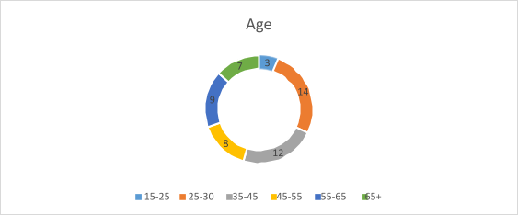

# Interpretation

As can be seen from the pie chart, majority belong to age group 25-35, followed by 35-45, 55-65, 65+ with the age group of 15-25 being the least.

# Analysis

* Majority of customer belongs to the age group of 25-35 and therefore we can state that the strategies used by Hyundai attracts young customers more as compared to those who are and above 45.
* Knowing that the majority of them are between 25-35 Hyundai can now implement more strategies to retain them and also simultaneously Generate new strategies to attract other age groups as well.
  1. Occupation of consumers?

|  |  |  |
| --- | --- | --- |
| Sr.no | Occupation | No. of People |
| 1 | Business | 16 |
| 2 | Professional | 10 |
| 3 | Employed | 17 |
| 4 | Self-Employed | 6 |
| 5 | Civil Service | 1 |
| 6 | Others | 3 |

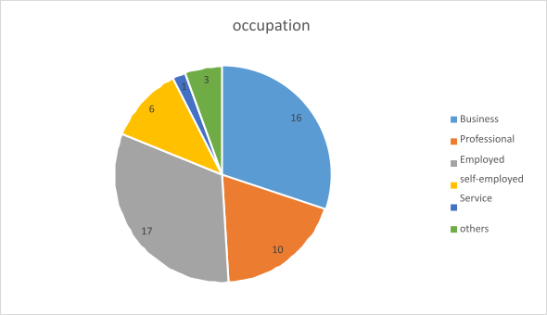

# Interpretation

As per the data, majority of people are employed, followed by people that own businesses, followed by professionals, with self-employed people, and people in other services following, and people in service sector being the least.

# Analysis

* Majority of consumers of Hyundai are either businessmen or are employees. Hyundai has different customer segments; they target upper middle classes of society income wise and therefore we can say that the company has been successful to achieve its targets pretty well.
  1. Annual Income of the Consumer?

|  |  |  |
| --- | --- | --- |
| Sr. no | Annual Income | No. of People |
| 1 | 0-10 Lakhs | 7 |
| 2 | 10-20 Lakhs | 9 |
| 3 | 20-30 Lakhs | 11 |
| 4 | 30-40 Lakhs | 14 |
| 5 | 40-50 Lakhs | 8 |
| 6 | 50 Lakhs + | 4 |

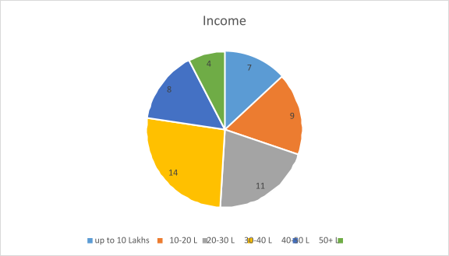

# Interpretation

Majority of the people follow in income category of 30-40 lakhs, with nearly same number of people in category of 20-30, 10-20, 40-50, 0-10 and least number of people in income category of 50 lakhs +

# Analysis

* Majority of the consumers are earning between 10 lakhs to 30 lakhs. Hyundai while formulating marketing strategies should not bother much about the budgets of their consumers.
* Consumer base of Hyundai has a Strong Purchasing power therefore they should adopt aggressive marketing strategies.
  1. Feature of Hyundai Consumer Like?

|  |  |  |
| --- | --- | --- |
| Sr. no | Feature | No. of People |
| 1 | Mileage | 8 |
| 2 | Price | 15 |
| 3 | Brand | 9 |
| 4 | Style | 3 |
| 5 | Mileage & Brand | 8 |
| 6 | Mileage & Style | 9 |

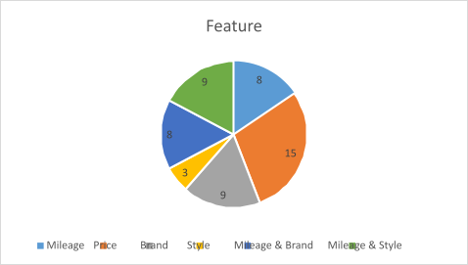

# Interpretation

15 people like price, 9 people like mileage and style, brand each, 8 people like mileage and brand, mileage each, 3 people liking the style.

# Analysis

* Hyundai is all about technology added with luxury for upper middle class segment customers. However, it is seen that price point is preferred by people, we know that Hyundai vehicle and service are slightly expensive and still people choose price.
* We can say that the price of Hyundai vehicle is justified.
  1. Type of customer?

|  |  |  |
| --- | --- | --- |
| Sr. no | Type | No. of People |
| 1 | Walk In | 13 |
| 2 | Click To Buy | 3 |
| 3 | Lead/ Reference | 20 |
| 4 | Through Promotion | 17 |

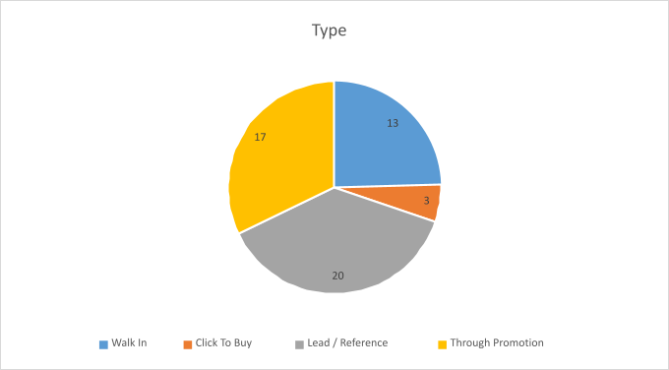

# Interpretation

Out of 53 consumers, 20 came via a reference, 17 came through promotion. 13 were walk in, with just 3 of them coming through click to buy feature.

# Analysis

* Hyundai received most of its customer as walk In. therefore it should focus more on this to maintain and improve their record of walk-in customers. This is followed by references and leads.
* Both the types indicates that customers are generated less by CTB and Promotions and therefore Hyundai should revise its spending on promotional events.
* Spending should be done more within the showroom.
  1. Were You offered Test-Drive?

|  |  |  |
| --- | --- | --- |
| Sr.no | Test Drive | Result |
| 1 | Yes | 47 |
| 2 | No | 6 |

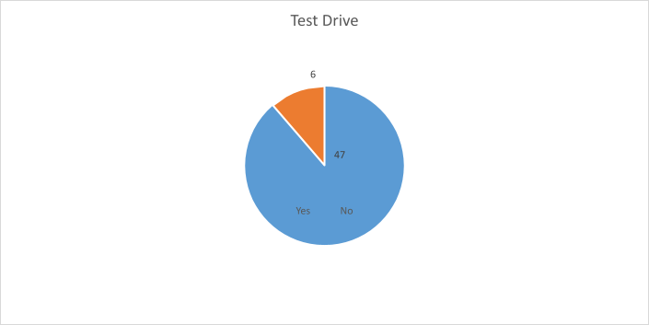

# Interpretation

Following shows the number of time Hyundai offered test drives to its customer out of 53. And data collected shows 47 times out of 53.

# Analysis

* Hyundai offers test drives to almost all of its customers, encouraging a test is very essential for customer satisfaction has it makes a customer confident about their purchase.
  1. Did they offer/ Serve Refreshments?

|  |  |  |
| --- | --- | --- |
| Sr.no | Refreshments | Result |
| 1 | Yes | 49 |
| 2 | No | 4 |

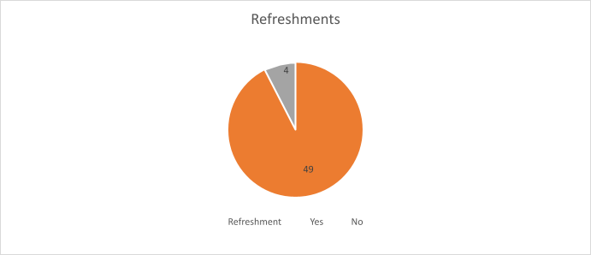

# Interpretation

Consumers were asked about the refreshments offered at Hyundai and as the data shows 49 customers out of 53 were asked and served refreshments.

# Analysis

* Offering or serving refreshments to the guest is an important to make customers satisfied, customers feel valued. Out of 53 times Hyundai has severed refreshments 49 times.
* Hyundai aims to serve refreshments to almost everyone.
  1. Rate your first interaction at showroom

|  |  |  |
| --- | --- | --- |
| Sr.no | Interaction | Result |
| 1 | Excellent | 9 |
| 2 | Good | 21 |
| 3 | Neutral | 13 |
| 4 | Could be better | 6 |
| 5 | Poor | 4 |



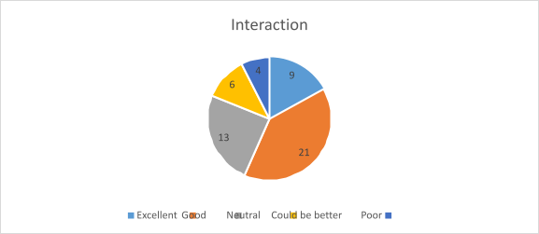

# Interpretation

21 rated their interaction at showroom as good, 13 rated neutral, 9 rating excellent, 6 rating could be better while 4 rating poor

# Analysis

* First impression is very crucial when it comes to customer satisfaction, Hyundai pays a close attention towards their first impress on customer.
* Majority of the consumers had a satisfying first impression and therefore we can say that Hyundai’s attempts to win the first impress has good success rate.
  1. How satisfactory was the expiation/ Pitch of the sales executive?

s

Sales Pitch

17

8

27

20

32

Excellent Good Neutral Could be better Poor

|  |  |  |  |  |
| --- | --- | --- | --- | --- |
| Sr.no | Sales pitch | | Result | |
| 1 | Excellent | | 8 | |
| 2 | Good | | 18 | |
| 3 | | Neutral | | 22 |
| 4 | | Could be better | | 5 |
| 5 | | Poor | | 0 |

# Interpretation

When asked about pitch of sales executive, 22 remained neutral, 18 rated good, 8 rated excellent, 5 rated could be better, while none of them rating poor

# Analysis

* + As the results for sales pitch of Hyundai stands neutral it is difficult to predict their connection with customers.
  + A good and convincing sales pitch helps to build a good business connection with your customer, Hyundai should push more for excellent sales pitch.

1. Were you encouraged to buy upgrades?

|  |  |  |
| --- | --- | --- |
| Sr.no | Encouraged | Result |
| 1 | Yes | 46 |
| 2 | No | 7 |

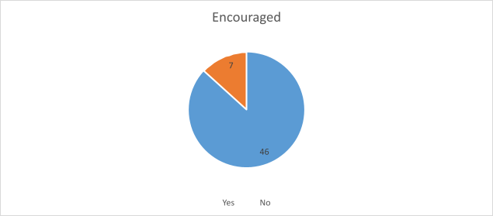

# Interpretation

Following data shows the level of upsell encouraged by Hyundai, almost every time that is pout of 53 times Hyundai did encourage its customer for upsell.

# Analysis

* + Hyundai formulates its strategies to eventually increase its revenue, however Hyundai tries to upsell in order to offer customer every option possible so that they can make an informed decision.
  + Most of the time Hyundai has encouraged upselling and thereby increased the chances of customer satisfaction and loyalty.

10. How was the Buying process (Paper work)?

|  |  |  |
| --- | --- | --- |
| Sr.no | Process | Result |
| 1 | Fast and Smooth | 12 |
| 2 | Smooth | 16 |

|  |  |  |
| --- | --- | --- |
| 3 | Neutral | 11 |
| 4 | Delay | 9 |
| 5 | Poor | 5 |

# Interpretation

16 felt the paper work was smooth, 12 feeling it was fast and smooth, 11 being neutral, 9 feeling it was delayed and 5 rating poor

# Analysis

* Hyundai customers overall has good experience of buying process and formalities. A good buying process is required for customer satisfaction and therefore it is seen that Hyundai tries to provide its customers with a good and satisfying buying experience.
* Buying process (paper work) is overall smooth and less confusing or tricky at Hyundai.

11.Did they Guide you well?

|  |  |  |
| --- | --- | --- |
| Sr.no | Guided | Result |
| 1 | Yes | 51 |
| 2 | No | 2 |

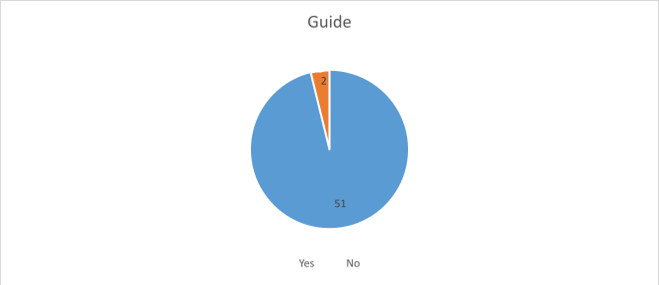

41

# Interpretation

Consumers were asked about the guidance they received by Hyundai and as can be seen Hyundai has Guided their customer 51 times on time out of 53 deliveries.

# Analysis

* Guiding your customer play an important role when it comes to customer satisfaction.
* Hyundai has an excellent rate for guiding it customers and therefore we can say that this end has generated a lot of satisfied customers.

12.How long was the waiting period?

|  |  |  |
| --- | --- | --- |
| Sr.no | Waiting Time | Result |
| 1 | Justified | 20 |
| 2 | Slightly long | 29 |
| 3 | Too long | 4 |

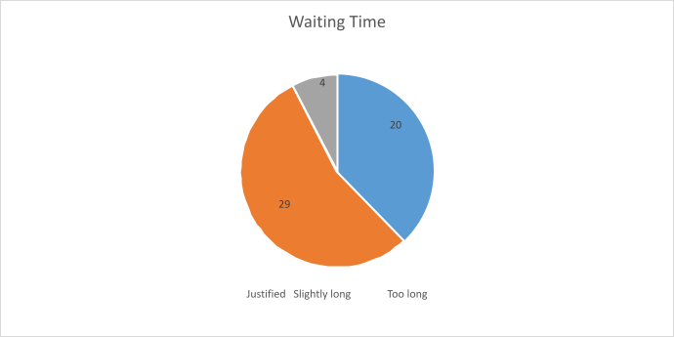

# Interpretation

29 people felt the waiting period was slightly long, 20 feeling it was justified and 4 saying the waiting period was too long

# Analysis

* Hyundai vehicles have a certain waiting period if the required vehicle is not available at yard. Usually, the waiting time rages from 4weeks to 6 weeks.
* Too much of waiting time can lead to customer dissatisfaction, however the time taken by Hyundai is seen to be acceptable as very few customers felt it takes too long.

1. Was the delivery on time?

Delivery

6

47

Yes No

|  |  |  |
| --- | --- | --- |
| Sr.no | Delivery | Result |
| 1 | Yes | 47 |
| 2 | No | 6 |

# Interpretation

Consumers were asked about the delivery timing of Hyundai and as expected Hyundai has delivered 47 times on time out of 53 deliveries.

# Analysis

* + Almost all the customers of Hyundai received their vehicle delivery on time. Hyundai has been pushing hard to deliver the vehicle as promised.
  + A strong sense of customer satisfaction is generated when the promise to deliver a vehicle is fulfilled. Therefore, Hyundai is doing great to generate consumer satisfaction.

14. What do you think about Hyundai’s Service?

|  |  |  |
| --- | --- | --- |
| Sr.no | Service | Result |
| 1 | Excellent | 7 |
| 2 | Good | 17 |
| 3 | Neutral | 13 |
| 4 | Could be better | 9 |
| 5 | Poor | 7 |

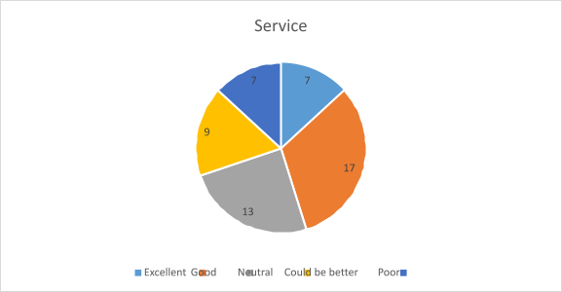

# Interpretation

In the following survey Hyundai’s consumer were asked about the service of Alcon Hyundai and the mentioned responses were collected, Majority of the consumer found the service to be just good while close to majority of them stood neutral, two extreme ends share the results with 7 votes each.

# Analysis

* + Nearly half of the respondents are satisfied with the service of Hyundai but a remarkable are upset over the service and therefore company has to look into the service department and analyses the actual problem.
  + The number of respondents who stood neutral can even go with the favor of those who are unsatisfied and therefore this can be a legit reason for customer dissatisfaction.

15.Are the spare parts easily available?

|  |  |  |
| --- | --- | --- |
| Sr.no | Spare parts | Result |
| 1 | Yes | 13 |
| 2 | No | 40 |

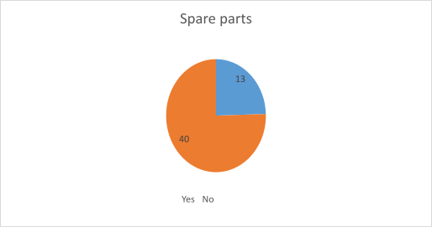

# Interpretation

Set of 53 consumers were asked about the availability of Hyundai spare parts and the results were; 40 consumers out of 53 could not avail the spare parts while only 13 of them could arrange for it.

# Analysis

* + Interpretation shows that customers who don’t find spare parts are more and therefore we can say that Hyundai’s spare parts are not easily available.
  + Hyundai should take this into consideration and work towards making the spare parts available this will increase their revenue from service department as well as help to retain customers are sales

16.Hyundai’s attitude after sales?

|  |  |  |
| --- | --- | --- |
| Sr.no | Attitude | Result |
| 1 | Excellent | 7 |
| 2 | Good | 18 |
| 3 | Neutral | 15 |
| 4 | Could be better | 6 |
| 5 | Poor | 7 |

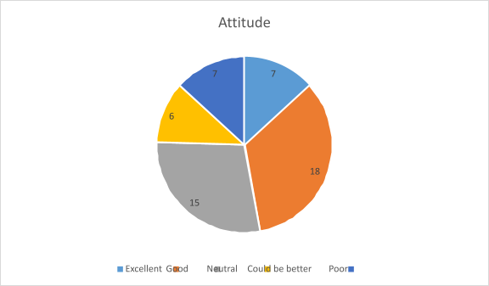

# Interpretation

Most people felt the attitude to be good, just less than majority of them saying neutral, same number of people saying the attitude was excellent and poor, with the least saying could be better

# Analysis

* + Company has been successful in maintaining a positive attitude with its existing consumers which shows that Hyundai has good after sales services.
  + Having a good and positive attitude as a part of after sales is what contributes significantly towards customer satisfaction.

18.Areas according to you where Hyundai needs to improve?

|  |  |  |
| --- | --- | --- |
| Sr.no | Improvement | Result |
| 1 | Products | 4 |
| 2 | Service | 25 |
| 3 | Employees Behavior | 8 |
| 4 | Waiting Period | 9 |
| 5 | Delivery Time | 7 |

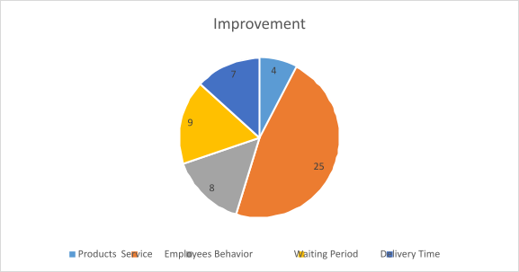

# Interpretation

Majority i.e., 25 of the respondents believe there is a need of improvement in service, with almost same number of people saying on waiting period, employee behavior and delivery time, with the least people feeling the need to improve the products

# Analysis

* + Consumer who suggested service is the area Hyundai needs to improve are the one who must have faced difficulty and inconvenience.
  + Inconvenience caused to customers is the direct reason for customer dissatisfaction and so Hyundai should implements required changes

19.Will you recommend Alcon Hyundai to your known ones?

|  |  |  |
| --- | --- | --- |
| Sr.no | Recommend | Result |
| 1 | Yes | 33 |
| 2 | No | 20 |

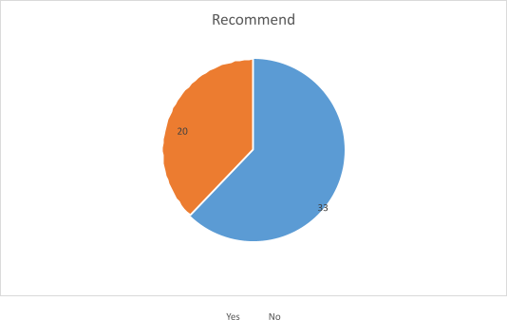

# Interpretation

When asked if they would refer Alcon Hyundai to known ones, majority of them i.e., 33 out of 53 said yes, while remaining said no

# Analysis

* + Although the majority of customers look satisfied with Hyundai but looking at the other side it is very clear the close to majority of them will not refer Hyundai to their known once.
  + Consumers those who choose not to refer Hyundai surely are the once who are not satisfied with Hyundai and its service provided, Company strongly need to work towards this issue.

**CHAPTER IV**

**RECOMMENDATIONS**

Counto Automobile Ltd. have strived to constantly put in efforts to keep abreast with needs of the customers and meet their satisfaction levels with the changes implemented during the Pandemic. Although the company proved to provide excellent sales services during the pandemic, the following recommendations will further help the company if implemented:

* As per the observation, the customers are satisfied with sales services offered by Alcon Hyundai, but they express concern and dissatisfaction over services provided by the servicing department of the company. It is suggested that the management could offer a quick service guide to their customers when they come for servicing and the department could also make ‘know how’ videos of common technical issues that take place and show it to the customer via an explanation so that the customer knows what is wrong with their vehicle and why.
* A lot of customers have expressed their dissatisfaction over lack of transparency when it comes to servicing. Customers do not receive clear information on the issues related to their vehicle which leads to dissatisfaction among them. Since the company has an interactive social media presence, it is suggested that they make more effective use of it by creating videos, info graphics or informative threads educating customers on car servicing, for example: they could give a demonstration on how the person can check their engine oil.
* Albeit, Alcon Hyundai boasts a huge customer base, they could also work towards attracting the younger population by introducing online competitions, gift hampers, etc. to attract potential customers.
* The target set for relationship managers in the company is 5 clients per month. Taking the pandemic into consideration, landing five clients in a month is extremely difficult for them. When meeting a potential client, the managers often do not disclose information on commitments and tentative delivery dates at the time of booking fearing that they might lose the client. This later leads to conflict and may affect the brand image due to negative word of mouth. The company has to reduce the number of targets set for a month in order reduce the pressure mounted on the relationship managers so that they communicate with their potential customers effectively with complete transparency.
* It is also suggested that the company conduct a lost customer analysis wherein they contact customers who were previously interested but gave up on the idea of a purchase

or switched to competitors. Companies need to contact customers who have halted buying or have switched to another supplier to find out why this has happened. Information on the reasons why a customer lost interest can help the company improve or learn more about how they can deal with similar customers in the future.

* Several customers have been complaining regarding the errors in the delivery process and timings. Therefore, this would be the area which I would suggest the showroom to pay focus on a little bit more. It needs to improvise its delivery process management and time. It needs to become a little quick and fast. Some of the customers have also complained about the post-purchase services provided by the showroom. Although the complaints are of minor issues, the showroom needs to look after and consider the customers’ issues after purchase in order to achieve customer satisfaction.

Counto Automobile Pvt. Ltd., a stop shop for sales, service and spare parts of Hyundai Vehicles is a well-known dealership in Arlem, Margao. Ever since its inception, the showroom has always ensured that it maintains a high standard when it comes to serving customers. The establishment endeavors to achieve the highest level of customer satisfaction and improve the buying experience for its customers. They have always been focused on offering customer delight. The Premium car showrooms combine the best of technology and human expertise.

The six weeks of internship Program at Alcon Hyundai, Fatorda, Margao was definitely a one to remember with valuable experience as I conducted my research and acquired knowledge from the department of sales to study customer satisfaction during the pandemic. The manager was always open to my many questions and provided me with answers in detail. The rest of the staff members were kind enough to assist me throughout my tenure of internship for completing the project.

The Internship Program has certainly broadened my knowledge on the functioning of automobile dealership and automobile service industries and all the interesting things that will inevitably help me in my future when I embark on my corporate quest after I successfully complete my post-graduation in MBA course at my college.

# Conclusion

1. Alcon Hyundai has always enjoyed a high patronage from its customers.
2. Most of the customers have always had a good experience of purchase at Alcon Hyundai.
3. The contentment levels can also be measured with the range of recommendations to friends and the associates; it is evident that customers are content with the services offered at Alcon Hyundai.
4. The probability of the customers repeating that purchase at the same showroom is high, which is a positive sign.
5. It has been noted that the customers have reported a slack in the delivery process. This is the only aspect of concern that has emerged from the city.

# Reference

[https://www.alcon-hyundai-porvorim.com](https://www.alcon-hyundai-porvorim.com/)

[https://www.alcon.hyundaimotor.in](https://www.alcon.hyundaimotor.in/) [https://www.alcon.com](https://www.alcon.com/) [https://www.hyundai.com](https://www.hyundai.com/)